**Tip Calculator**

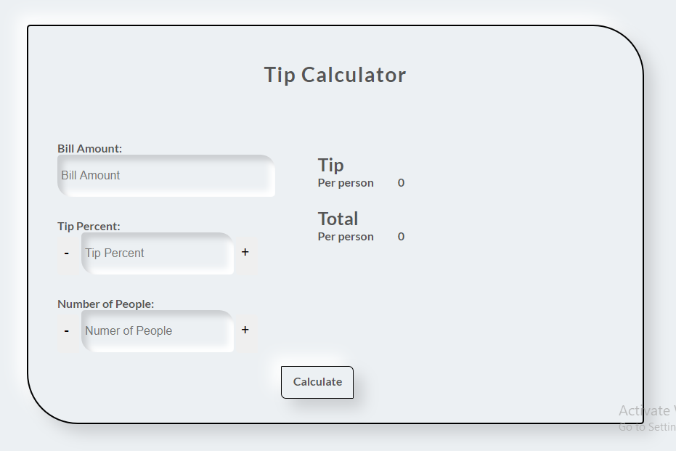

**Calculator Test Cases**

|  |  |  |  |  |  |
| --- | --- | --- | --- | --- | --- |
| **S.No** | **Bill** | **Tip** | **Person** | **Tip per person** | **Total per person** |
| 1 | 500 | 10% | 2 | 25.00 | 275.00 |
| 2 | 1000 | 0% | 2 | 0.00 | 500.00 |
| 3 | 0 | 50% | 1 | Invalid input |  |
| 4 | 100 | 40% | 0 | Invalid input |  |
| 5 | -500 | 10% | 5 | Invalid input |  |
| 6 | 10000 | 1% | 4 | 25.00 | 2525.00 |
| 7 | 10HII | 50% | 10 | Invalid input |  |
| 8 | 10^5 | 5% | 0 | Invalid input |  |
| 9 | 10e^9 | 14% | 6 | Invalid input |  |
| 10 | 450 | 110% | 15 | 33.00 | 63.00 |
| 11 | 1000000000000 | 5% | 5 | 10000000000.00 | 210000000000.00 |
| 12 | Hello | 5% | 10 | Invalid input |  |
| 13 | 500 | 4% | 1050 | 0.04 | 1.01 |
| 14 | 6000 | 205% | 104 | 118.27 | 175.96 |
| 15 | - | - | - | Invalid input |  |
| 16 | 700 | 0 | 2 | 0.00 | 350.00 |
| 17 | 500 | 8% | - | Invalid input |  |
| 18 | 10.789.55 | 4% | 9 | Invalid input |  |
| 19 | 15.78 | 5% | 3 | 0.26 | 5.52 |
| 20 | 450.4520 | 4% | 1 | 18.02 | 468.47 |